CODIGO DE EVENTOS BCAA.12-18042021 (Isla Rey Jorge, Antártida)

Reporte semanal
12 al 18 abril, 2021

Información general
En el área de análisis (Islas Shetland del Sur, Antártida) han sido estudiados enjambres sísmicos como el que se inició el 28 de agosto del 2020. En el periodo comprendido entre el 12 y el 18 de abril del 2021 se parametrizaron 98 eventos de los cuales 39 tienen M_{Lz} mayores a 4 (ver tabla 1).
La mayoría de los eventos sísmicos están vinculados al movimiento producido por de fallamiento. Estas estructuras presentan direcciones ENE limitando la cuenca de Bransfield (Figura 1). Otras estructuras superficiales importantes mapeadas previamente presentan direcciones NNO en la que se incluye también a la falla Artigas que limita dos bloques de distinto espesor cortical en la placa Shetland del Sur.

Tabla 1. Listado de eventos parametrizados

día | mes | año | MLz | To | distancia epicentral (km) | Profundidad (km) | Lat (°) | Long (°)
12 | 4 | 2021 | 4,61 | 20:56:10 | 20,3 | 14,33 | -62,200 | -58,461
13 | 4 | 2021 | 3,48 | 8:37:59 | 23,0 | 8,64 | -62,046 | -58,523
13 | 4 | 2021 | 3,88 | 9:29:02 | 17,2 | 16,44 | -62,338 | -58,817
13 | 4 | 2021 | 3,90 | 9:35:05 | 19,8 | 11,93 | -62,352 | -58,721
13 | 4 | 2021 | 3,74 | 9:38:20 | 20,3 | 11,71 | -62,367 | -58,879
13 | 4 | 2021 | 4,33 | 9:42:09 | 16,5 | 15,85 | -62,317 | -58,707
13 | 4 | 2021 | 3,42 | 9:45:30 | 18,7 | 13,91 | -62,346 | -58,752
13 | 4 | 2021 | 4,18 | 9:48:01 | 15,7 | 17,19 | -62,325 | -58,878
13 | 4 | 2021 | 3,88 | 9:48:47 | 17,9 | 15,05 | -62,182 | -59,196
13 | 4 | 2021 | 4,15 | 9:50:03 | 19,7 | 12,91 | -62,353 | -58,735
13 | 4 | 2021 | 3,32 | 9:54:56 | 19,5 | 13,29 | -62,334 | -59,045
13 | 4 | 2021 | 3,94 | 9:59:21 | 20,4 | 12,28 | -62,367 | -58,804
13 | 4 | 2021 | 3,69 | 10:17:30 | 20,3 | 11,72 | -62,327 | -58,605
13 | 4 | 2021 | 3,90 | 20:46:30 | 24,9 | 10,93 | -62,208 | -59,330
14 | 4 | 2021 | 3,47 | 3:25:07 | 23,2 | 8,71 | -62,077 | -58,469
15 | 4 | 2021 | 3,69 | 12:17:54 | 24,0 | 8,07 | -62,240 | -58,405
15 | 4 | 2021 | 3,50 | 17:45:51 | 21,8 | 15,50 | -62,375 | -58,758
16 | 4 | 2021 | 2,85 | 1:42:54 | 14,9 | 8,25 | -62,318 | -58,812
16 | 4 | 2021 | 4,48 | 18:14:10 | 23,2 | 11,19 | -62,034 | -58,541
16 | 4 | 2021 | 4,09 | 18:15:55 | 21,5 | 14,67 | -62,337 | -58,597
16 | 4 | 2021 | 3,92 | 18:48:36 | 23,2 | 10,16 | -62,377 | -59,027
16 | 4 | 2021 | 4,05 | 19:38:12 | 6,9 | 20,96 | -62,216 | -58,739
16 | 4 | 2021 | 5,20 | 19:47:11 | 11,3 | 26,77 | -62,229 | -58,656
16 | 4 | 2021 | 4,17 | 20:23:09 | 19,8 | 17,43 | -62,341 | -58,667
16 | 4 | 2021 | 4,32 | 20:28:23 | 20,8 | 16,09 | -62,223 | -58,460
16 | 4 | 2021 | 3,87 | 20:32:32 | 21,2 | 17,10 | -62,129 | -58,462
16 | 4 | 2021 | 4,11 | 20:45:09 | 19,3 | 18,16 | -62,232 | -58,494
16 | 4 | 2021 | 3,84 | 20:47:22 | 21,2 | 15,79 | -62,302 | -58,529
16 | 4 | 2021 | 4,16 | 20:47:51 | 21,3 | 15,81 | -62,317 | -58,557
17 | 4 | 2021 | 4,41 | 0:53:23 | 23,7 | 15,54 | -62,307 | -58,477
17 | 4 | 2021 | 3,36 | 1:45:11 | 26,5 | 6,90 | -62,222 | -58,347
17 | 4 | 2021 | 3,19 | 2:00:46 | 13,1 | 23,82 | -62,221 | -59,092
17 | 4 | 2021 | 3,10 | 2:52:44 | 26,8 | 10,64 | -62,364 | -58,505
17 | 4 | 2021 | 3,57 | 2:59:27 | 25,4 | 11,14 | -62,383 | -59,097
17 | 4 | 2021 | 3,05 | 3:24:46 | 26,2 | 5,39 | -62,362 | -58,521
17 | 4 | 2021 | 3,93 | 3:34:22 | 20,5 | 16,59 | -62,213 | -58,461
17 | 4 | 2021 | 3,65 | 4:21:51 | 17,3 | 21,43 | -62,102 | -58,569
17 | 4 | 2021 | 3,52 | 5:54:11 | 21,0 | 18,47 | -62,204 | -58,449
17 | 4 | 2021 | 3,97 | 9:19:28 | 23,7 | 16,86 | -62,264 | -58,429
17 | 4 | 2021 | 3,81 | 9:41:27 | 22,3 | 17,26 | -62,240 | -58,439
17 | 4 | 2021 | 3,56 | 10:35:07 | 22,6 | 13,02 | -62,247 | -58,438
17 | 4 | 2021 | 3,31 | 10:47:57 | 23,3 | 10,20 | -62,263 | -58,436
17 | 4 | 2021 | 3,20 | 19:49:52 | 23,1 | 17,92 | -62,329 | -58,531
17 | 4 | 2021 | 3,64 | 20:43:15 | 22,1 | 18,61 | -62,334 | -58,572
18 | 4 | 2021 | 4,04 | 0:44:47 | 23,3 | 11,75 | -62,313 | -58,498
18 | 4 | 2021 | 3,50 | 0:55:54 | 25,0 | 14,42 | -62,307 | -58,448
18 | 4 | 2021 | 3,36 | 0:57:08 | 25,4 | 12,83 | -62,208 | -58,364
18 | 4 | 2021 | 3,11 | 1:02:46 | 24,2 | 10,09 | -62,089 | -58,433
18 | 4 | 2021 | 2,95 | 1:09:31 | 25,2 | 6,10 | -62,401 | -58,710
18 | 4 | 2021 | 3,46 | 1:12:40 | 18,9 | 16,63 | -62,178 | -58,487
18 | 4 | 2021 | 3,51 | 1:19:44 | 21,3 | 13,97 | -62,305 | -58,532
18 | 4 | 2021 | 4,38 | 1:37:10 | 24,2 | 9,57 | -62,360 | -58,578
18 | 4 | 2021 | 3,82 | 1:53:23 | 19,0 | 17,40 | -62,170 | -58,487
18 | 4 | 2021 | 3,54 | 1:54:14 | 26,7 | 11,11 | -61,995 | -58,535
18 | 4 | 2021 | 3,96 | 1:54:24 | 22,2 | 12,25 | -62,321 | -58,539
18 | 4 | 2021 | 4,12 | 1:55:10 | 25,0 | 9,89 | -62,246 | -58,389
18 | 4 | 2021 | 4,14 | 1:56:53 | 19,4 | 18,53 | -62,341 | -58,688
18 | 4 | 2021 | 3,44 | 1:58:46 | 22,6 | 12,45 | -62,199 | -58,418
18 | 4 | 2021 | 3,62 | 2:00:54 | 21,1 | 15,67 | -62,135 | -58,459
18 | 4 | 2021 | 3,58 | 2:03:20 | 21,1 | 15,00 | -62,342 | -58,625
18 | 4 | 2021 | 3,77 | 2:04:21 | 26,0 | 6,29 | -62,225 | -58,359
18 | 4 | 2021 | 3,64 | 2:04:45 | 22,2 | 14,54 | -62,198 | -58,425
18 | 4 | 2021 | 3,52 | 2:07:38 | 23,9 | 10,00 | -62,298 | -58,462
18 | 4 | 2021 | 4,11 | 2:09:21 | 23,5 | 10,82 | -62,260 | -58,428
18 | 4 | 2021 | 3,89 | 2:10:06 | 23,5 | 11,32 | -62,320 | -58,505
18 | 4 | 2021 | 5,25 | 2:15:15 | 22,6 | 13,61 | -62,326 | -58,538
18 | 4 | 2021 | 4,14 | 2:16:28 | 24,2 | 10,60 | -62,244 | -58,403
18 | 4 | 2021 | 3,62 | 2:19:30 | 19,5 | 17,15 | -62,300 | -58,568
18 | 4 | 2021 | 3,64 | 2:21:00 | 23,6 | 10,36 | -62,254 | -58,421
18 | 4 | 2021 | 4,24 | 2:21:13 | 24,3 | 10,00 | -62,403 | -58,852
18 | 4 | 2021 | 4,11 | 2:22:33 | 23,5 | 11,32 | -62,267 | -58,435
18 | 4 | 2021 | 4,00 | 2:24:20 | 23,9 | 8,98 | -62,272 | -58,431
18 | 4 | 2021 | 4,48 | 2:42:22 | 26,0 | 1,75 | -62,394 | -58,632
18 | 4 | 2021 | 4,10 | 2:59:00 | 22,4 | 12,34 | -62,379 | -58,740
18 | 4 | 2021 | 3,88 | 3:08:50 | 21,1 | 14,40 | -62,356 | -58,680
18 | 4 | 2021 | 4,63 | 3:16:51 | 21,4 | 15,25 | -62,338 | -58,604
18 | 4 | 2021 | 3,94 | 3:22:19 | 12,6 | 22,99 | -62,266 | -58,683
18 | 4 | 2021 | 3,85 | 3:25:01 | 15,8 | 21,06 | -62,253 | -58,586
18 | 4 | 2021 | 4,02 | 3:30:30 | 20,1 | 16,24 | -62,255 | -58,495
18 | 4 | 2021 | 4,71 | 3:46:30 | 21,7 | 15,47 | -62,334 | -58,583
18 | 4 | 2021 | 4,21 | 4:04:01 | 24,7 | 11,92 | -62,355 | -58,545
18 | 4 | 2021 | 3,90 | 4:07:45 | 16,1 | 20,46 | -62,276 | -58,610
18 | 4 | 2021 | 4,09 | 4:10:10 | 17,0 | 19,52 | -62,244 | -58,550
18 | 4 | 2021 | 3,88 | 4:17:59 | 9,0 | 23,75 | -62,265 | -58,849
18 | 4 | 2021 | 4,16 | 4:25:24 | 24,6 | 9,73 | -62,281 | -58,426
18 | 4 | 2021 | 4,25 | 4:34:22 | 36,7 | 10,00 | -62,441 | -58,406
18 | 4 | 2021 | 3,70 | 4:51:19 | 23,7 | 11,40 | -62,321 | -58,502
18 | 4 | 2021 | 3,67 | 4:53:43 | 20,0 | 15,48 | -62,277 | -58,522
18 | 4 | 2021 | 4,24 | 4:59:50 | 21,1 | 11,66 | -62,282 | -58,503
18 | 4 | 2021 | 4,86 | 5:18:09 | 21,7 | 16,10 | -62,291 | -58,502
18 | 4 | 2021 | 3,78 | 5:30:46 | 23,2 | 11,70 | -62,221 | -58,412
18 | 4 | 2021 | 4,09 | 5:32:18 | 22,4 | 12,93 | -62,216 | -58,425
18 | 4 | 2021 | 4,93 | 6:46:54 | 23,3 | 12,85 | -62,360 | -58,607
18 | 4 | 2021 | 4,62 | 6:48:37 | 18,6 | 17,80 | -62,336 | -58,700
18 | 4 | 2021 | 4,06 | 7:46:43 | 25,0 | 6,05 | -62,341 | -58,505
18 | 4 | 2021 | 3,83 | 7:58:19 | 21,9 | 13,75 | -62,381 | -58,830
18 | 4 | 2021 | 3,95 | 8:31:56 | 23,6 | 14,20 | -62,362 | -58,604
18 | 4 | 2021 | 4,34 | 10:04:38 | 30,0 | 6,71 | -62,156 | -59,427
18 | 4 | 2021 | 3,42 | 13:46:01 | 25,0 | 6,50 | -62,406 | -58,777

La fecha y la hora corresponden al momento en que el terremoto ocurrió. La hora está expresada en UTC (Universal Time Coordinated, por sus siglas en inglés), aproximadamente tres horas adelantadas de Uruguay y expresada en formato de 24 horas.

Es posible que otros eventos ocurriesen, pero debido a gaps y ruido antrópico no se han podido parametrizar. En la Figura 1 se muestra la localización de los epicentros de los sismos.
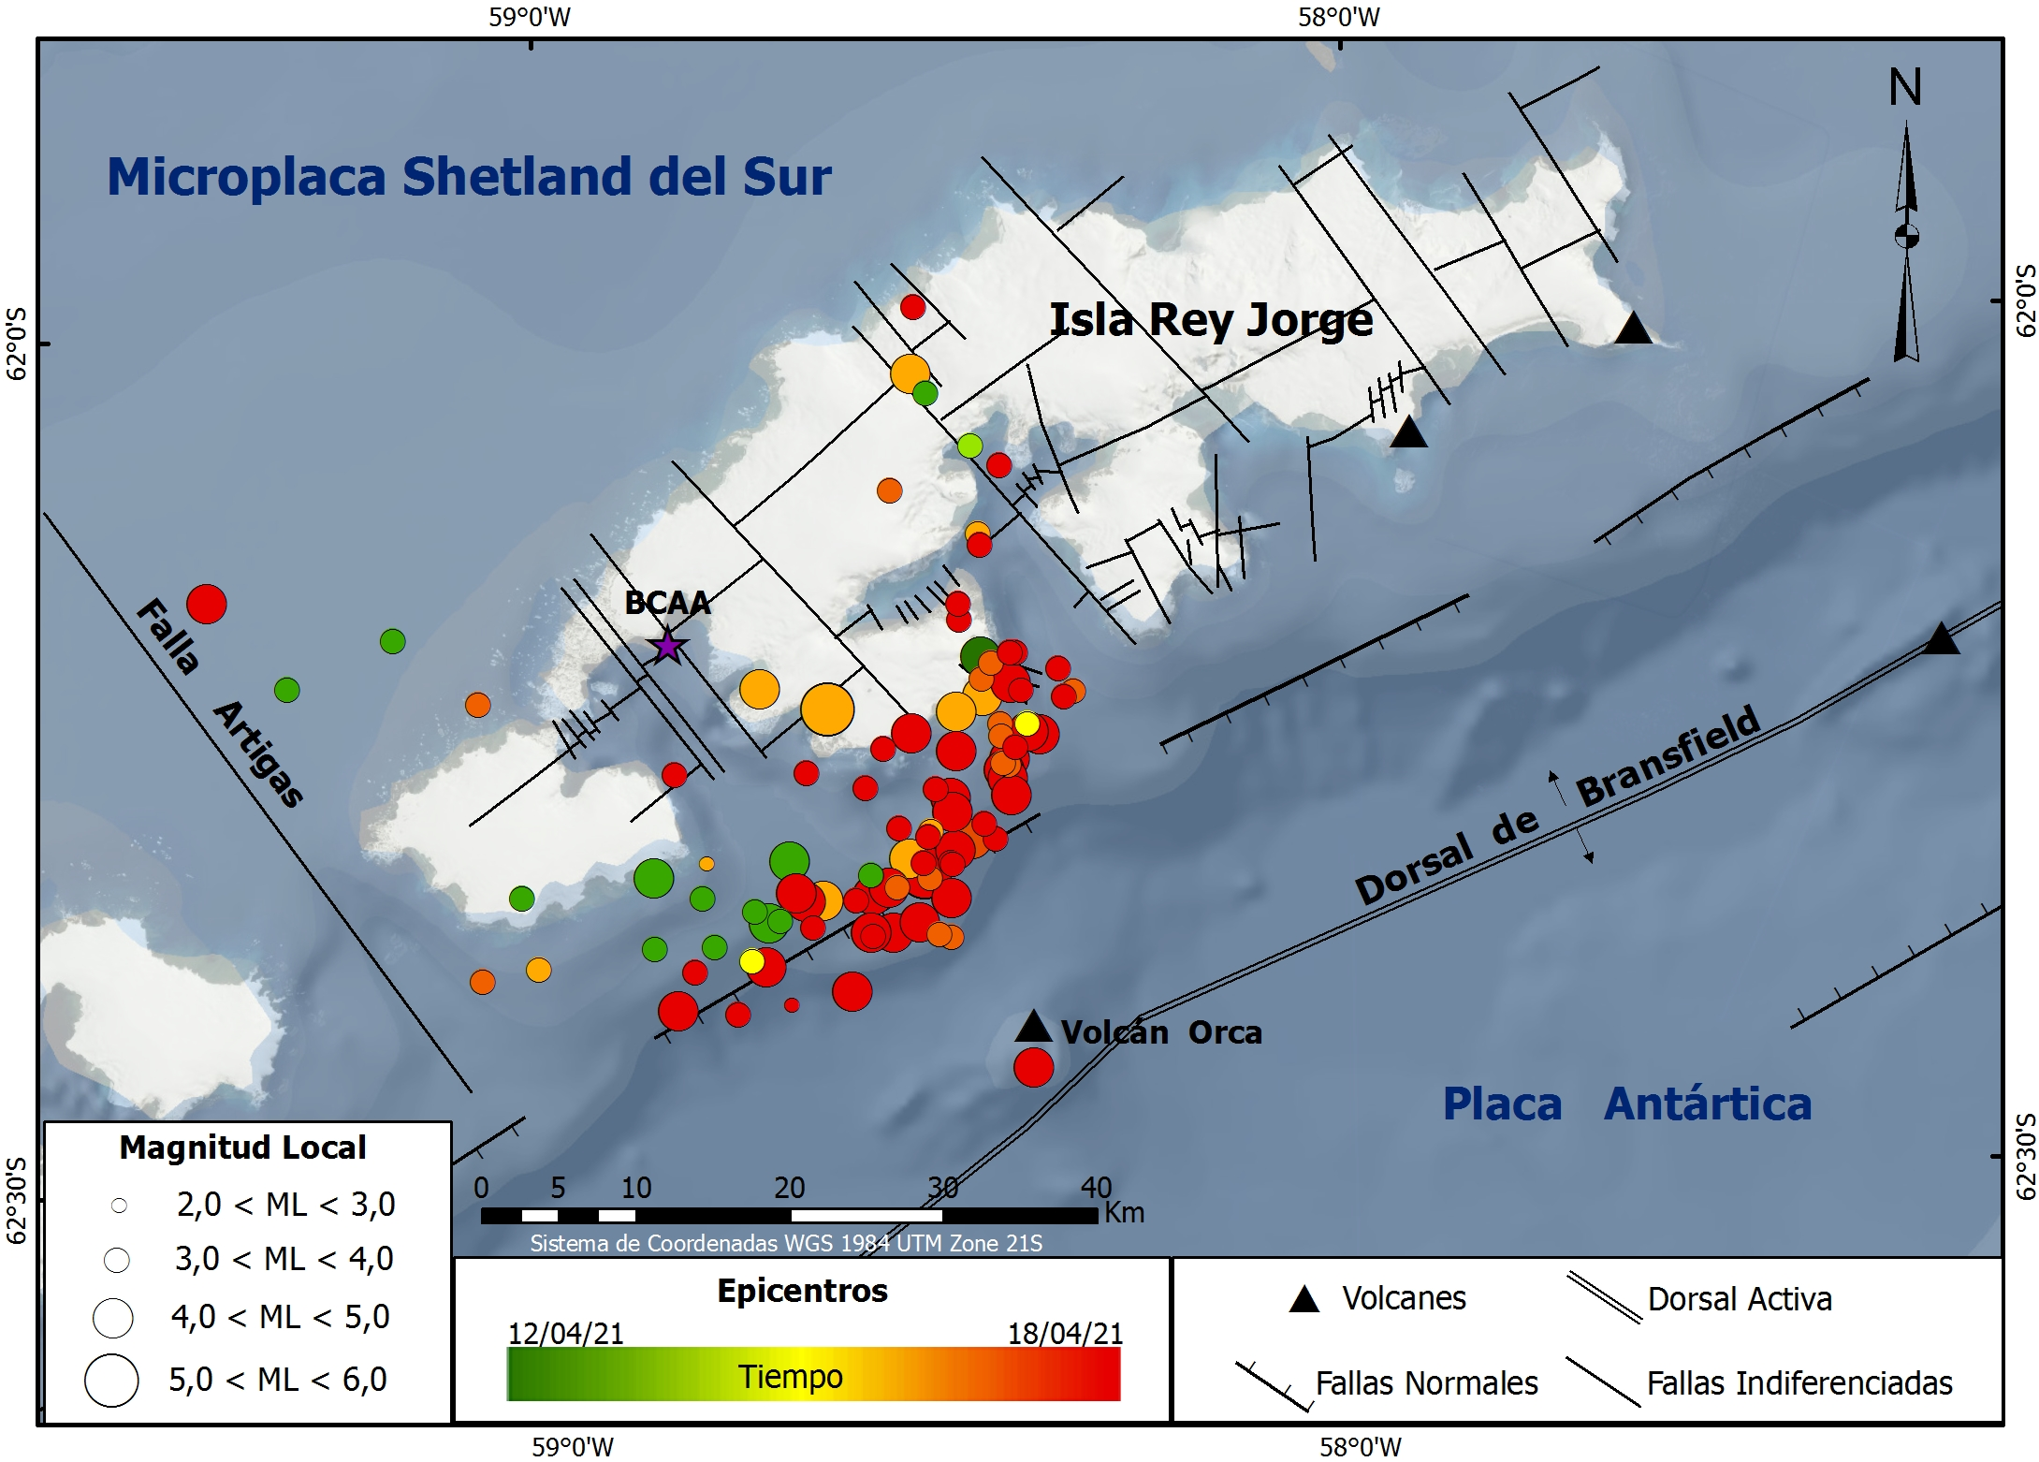
Figura 1. Mapa de localización de los epicentros de los sismos ocurridos en el periodo 12/04/2021-18/04/2021.
En la Figura 2 se muestran la forma de onda del evento del día 18/04/2021 (02:15:15) de MLz = 5.25 registrado en la estación R4DE2.
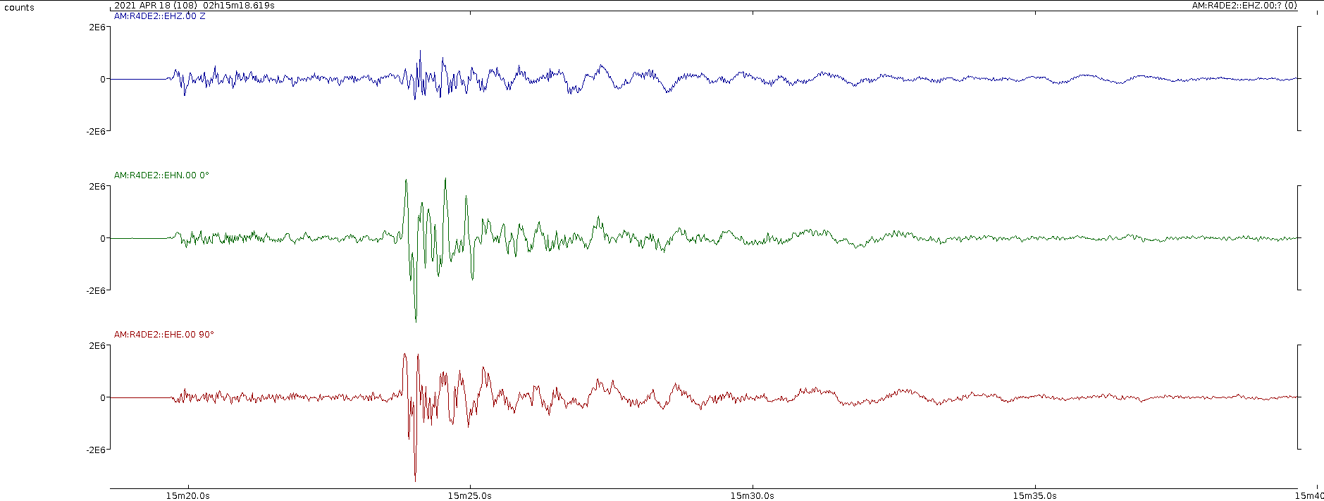
Figura 2. Forma de onda del evento sísmico ocurrido el día 10/04/2021 a las 07:14:03.

Leda Sánchez Bettucci, Observatorio Geofísico del Uruguay, Facultad de Ciencias, UDELAR.
Judith Loureiro, Dirección Nacional de Minería y Geología, MIEM, Observatorio Geofísico del Uruguay

